SPRINT -III

|  |  |
| --- | --- |
| Team ID | PNT2022TMID33942 |
| Project Name | ANALYTICS FOR HOSPITAL HEALTH CARE DATA |

**DASHBOARD:**

Dashboards are a collection of widgets that give you an overview of the reports and metrics you care about most. Dashboards let you monitor many metrics at once, so you can quickly check the health of your accounts or see correlations between different reports. Dashboards are easy to create, customize and share.

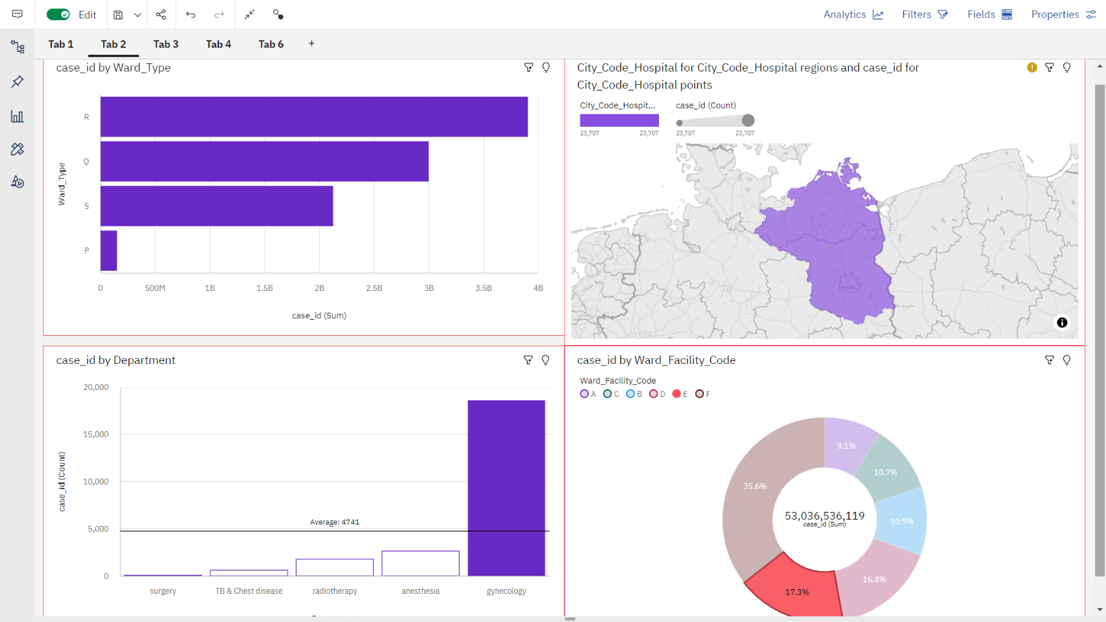

Data scientist can veiw case id ward type by clicking the specific case id ( ward facility).It also shows variation in department .

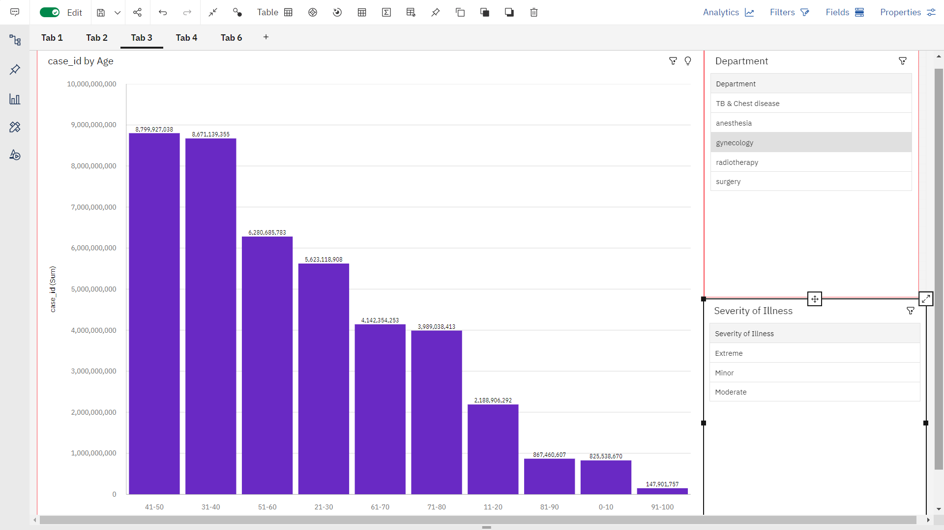

Data scientist can view variation in age by clicking the needed department from the list .

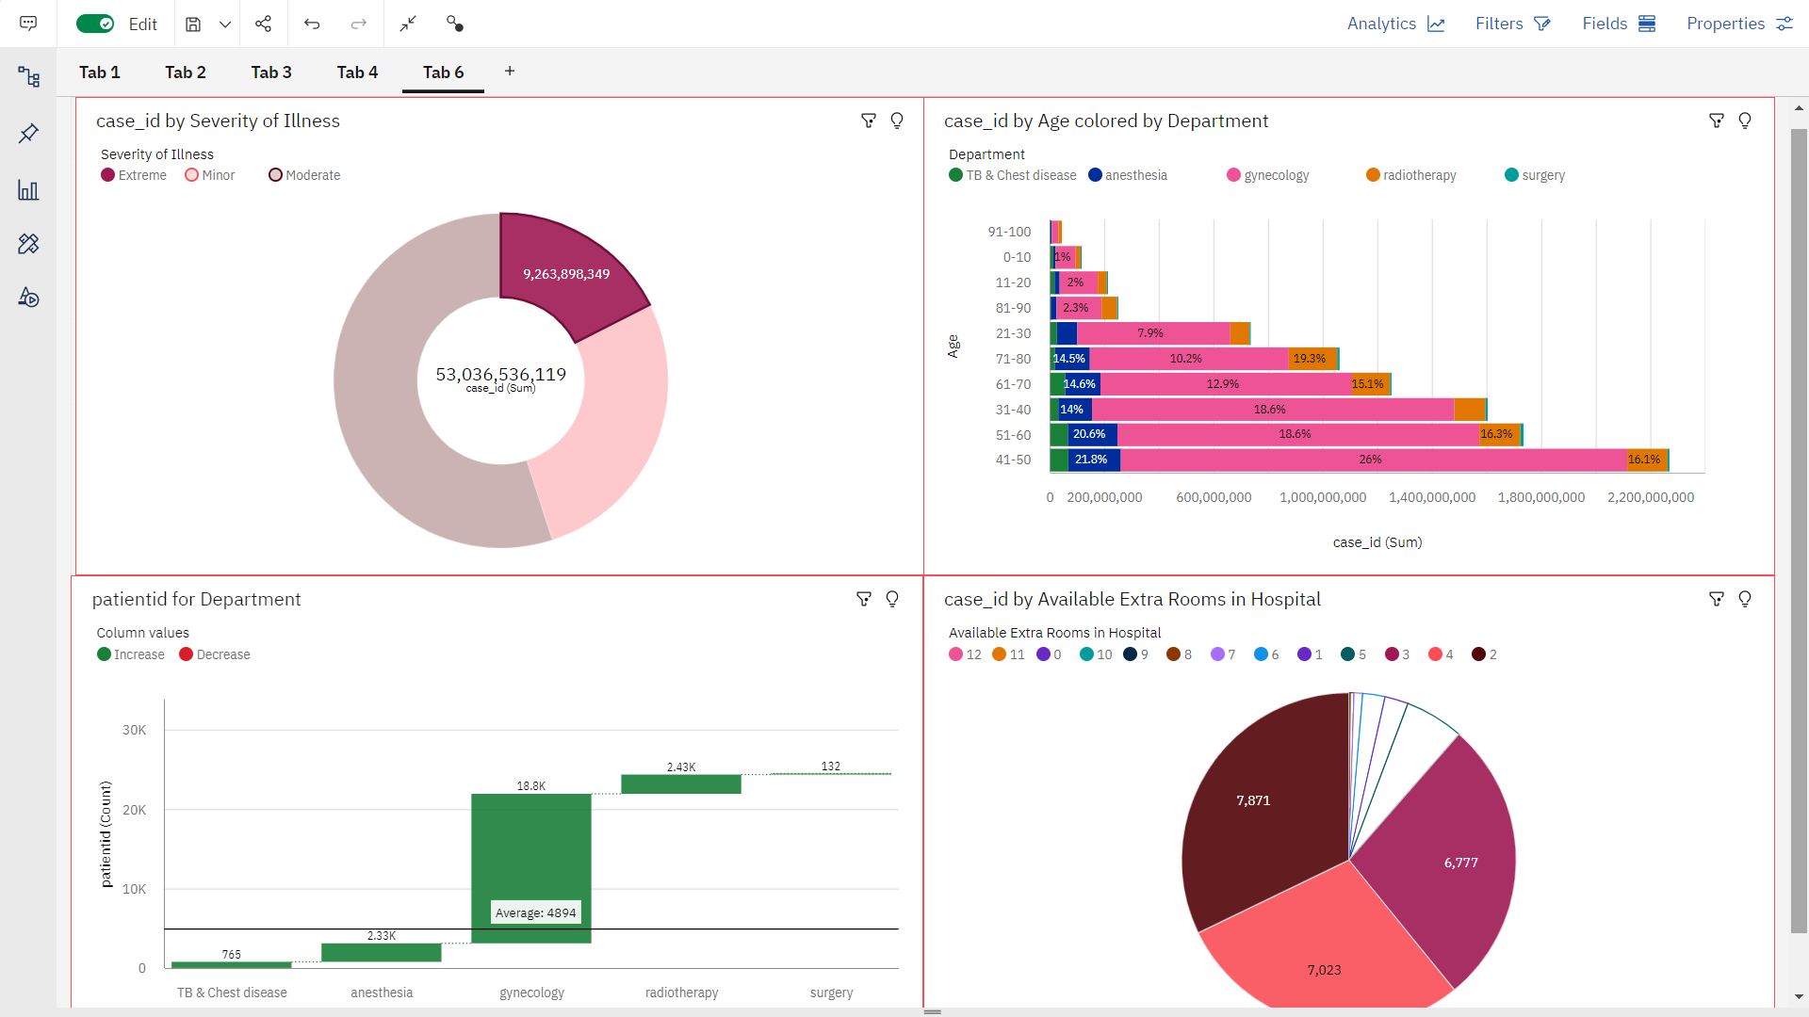

Data scientist can view the age color by department , patient id for department and available extra rooms in hospital by just clicking needed severity of illness.